**How to Insert WordArt with**

**rotation in Microsoft word 365**

**Step-by-Step Instructions**

**-lovepreet singh**

**How to Insert WordArt with rotation in Microsoft word 365**

**Step-by-Step Instructions**

The purpose of this document is to provide step to step instructions to insert WordArt in Microsoft Word 365

1. Open Microsoft word 365.The Word Windows should open as shown in figure 1.

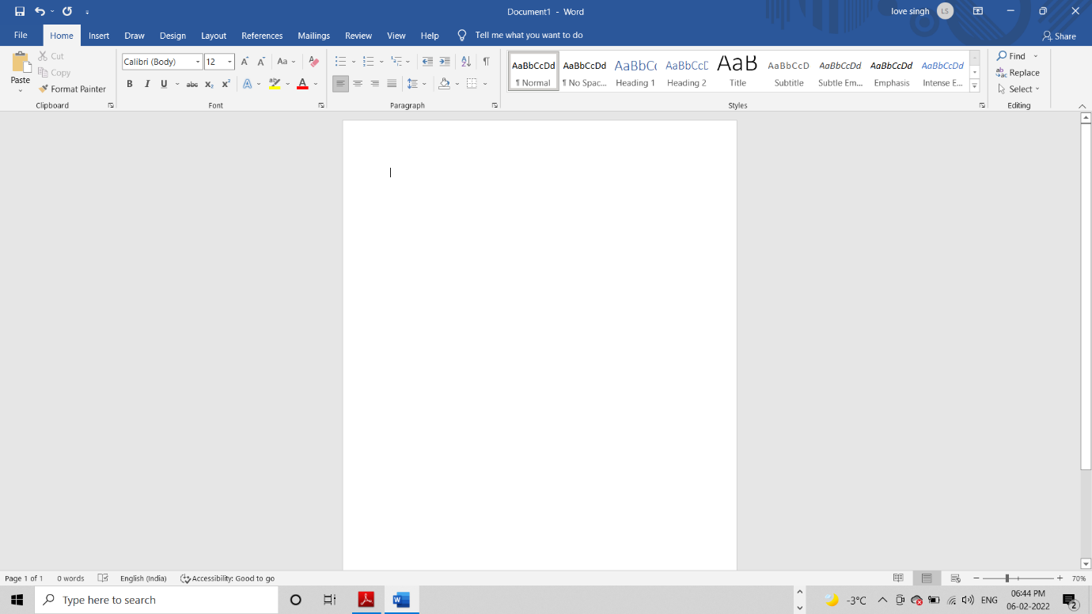Figure1:Microsoft Word 365 with a blank document

1. Click the **Insert** tab as show in figure2

Insert Tab

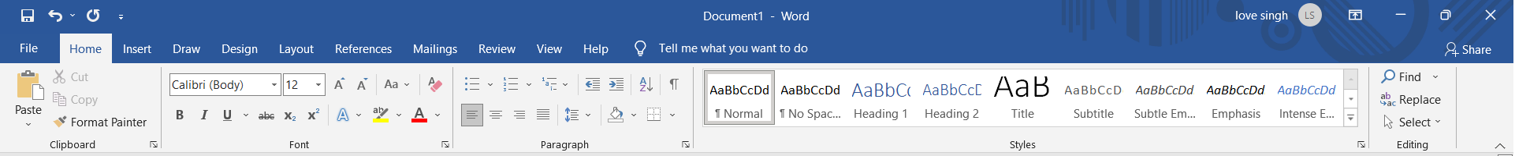

Figure2: Ribbon in Microsoft Word 365

1. In **insert tab**,in the **Text** group,click the **WordArt** arrrow as in Figure3.

WordArt

Insert Tab

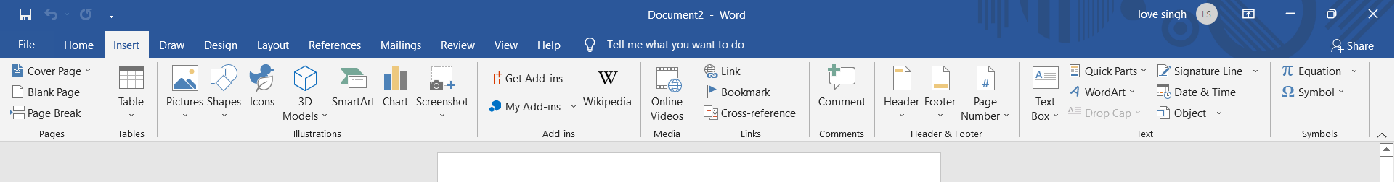

Text Group

Figure3: Ribbon in Microsoft Word 365

WordArt arrow

The list of available WordArt will display as shown in figure 4.

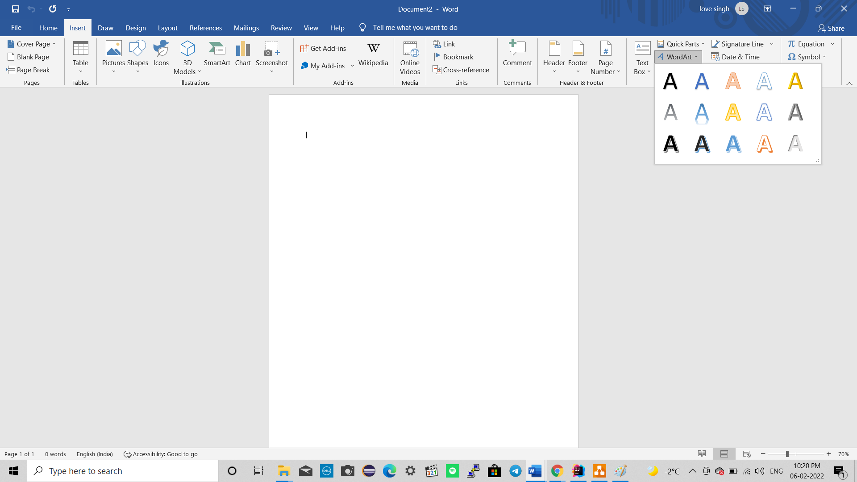

Fill: Black ,text colour 1, Shadow

Figure4: List of available word Arts.

1. Select the (Fill: Black ,text colour 1, Shadow ) option as shown in figure4
2. 5.WordArt would show up with “Your text Here written in the box” as shown in figure5.

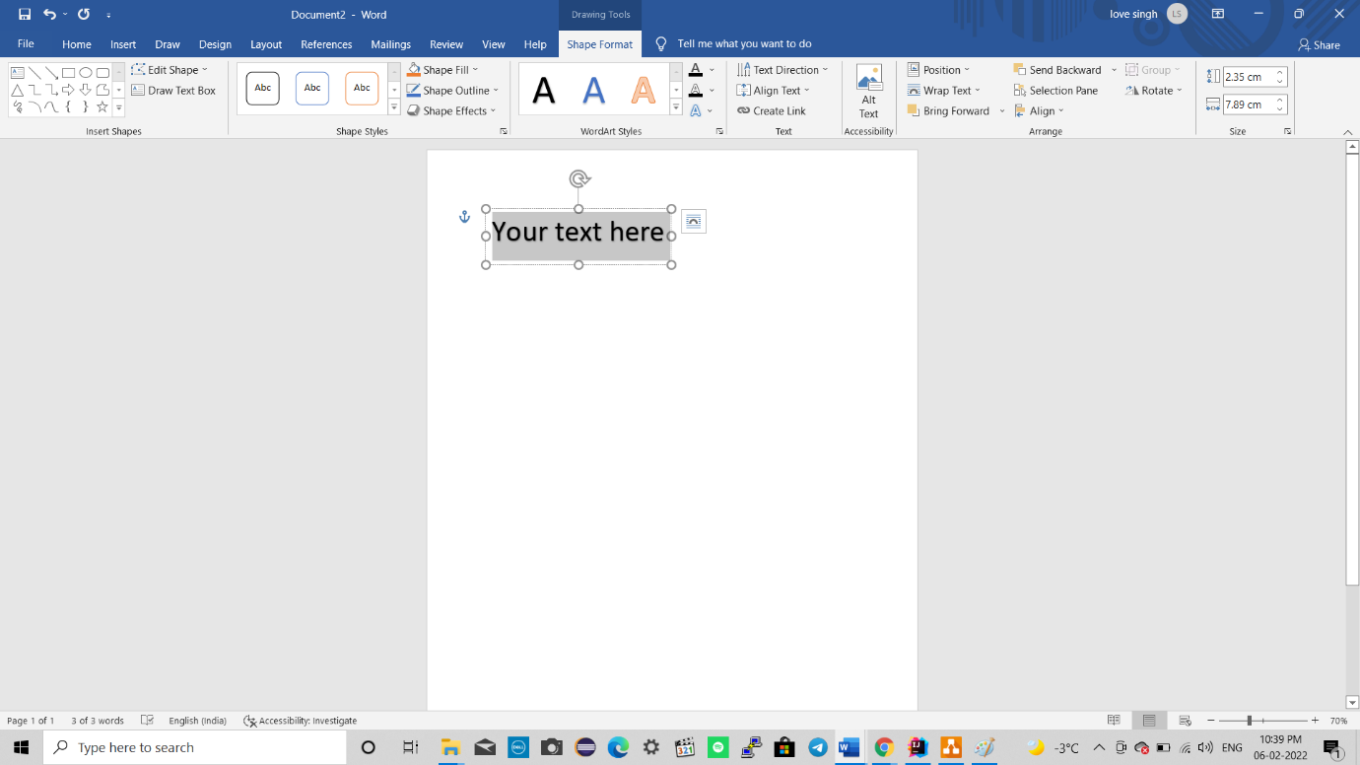Figure5: Word Art selected.

1. **Type: “Lovepreet singh”.**
2. On the Shape **Format** tab, in **the Arrange** group, click the **Rotate** arrow as shown in figure6.
3. Click on More Rotational options in the drop down, as shown in fig6.

Rotate arrow

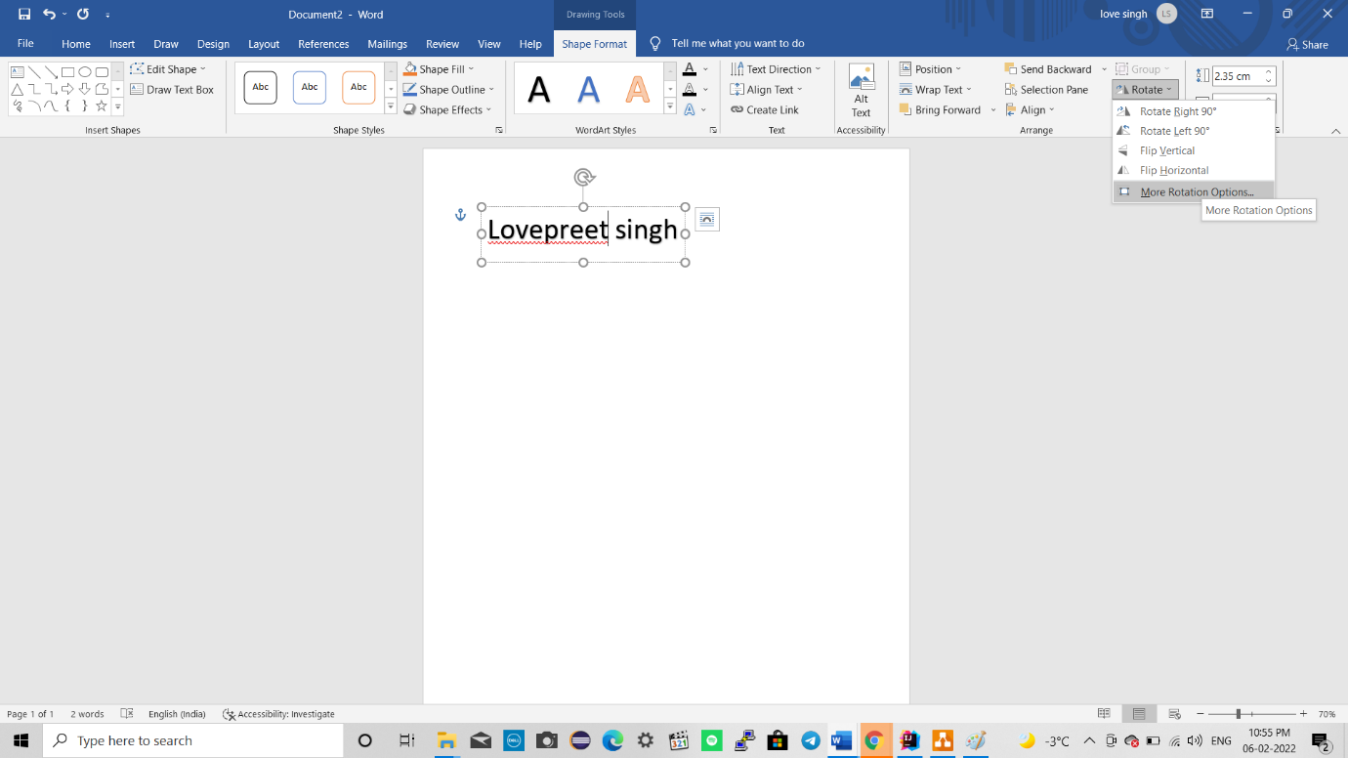

More Rotational Options…

Arrange group

Figure6:Rotate option of rotate

1. On the **Size** tab,in **Rotate** group in **Rotation** write 20 as shown in figure7.
2. Click on **ok** button to apply the Rotation .

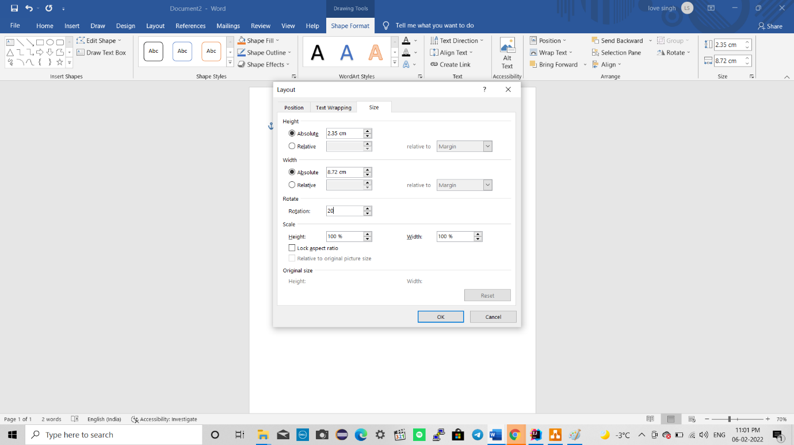

Size

Ok button

Rotation

Figure7:The layout settings for size.

1. .Rotation of 20 degree would be applied on WordArt as shown in figure 8.

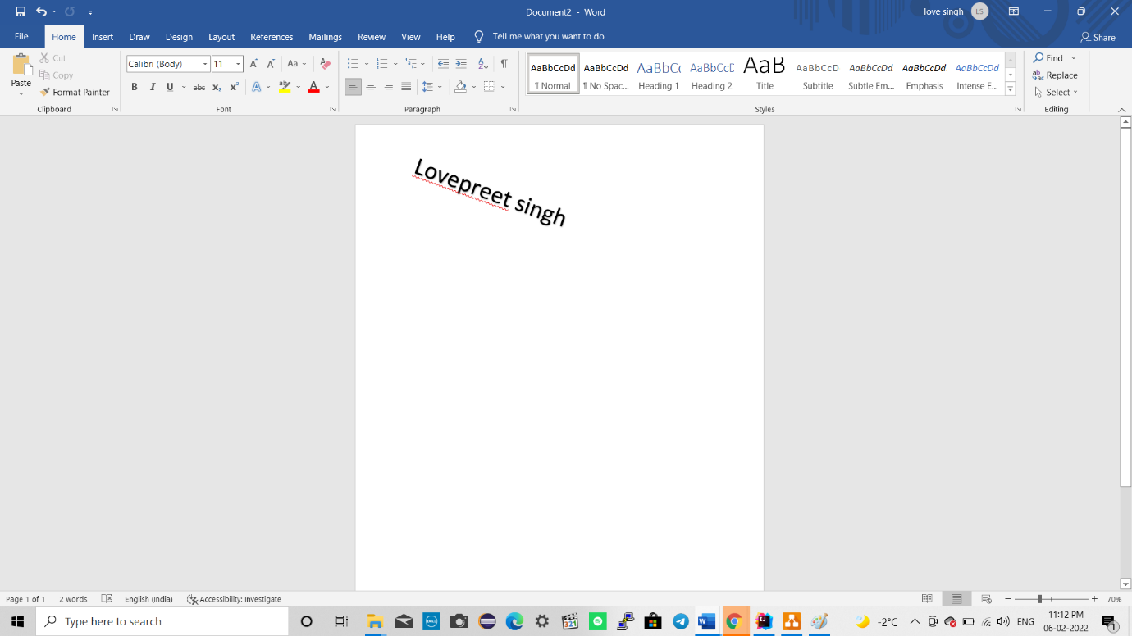

Figure8:WordArt with rotation.

**Using this method, you can apply rotation to the created WordArt.**